**RBT (Rip Bad Tea)**

1. Here's the original tree ..

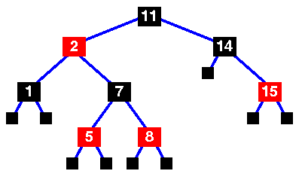

1. The tree insert routine has just been called to insert node "4" into the tree.

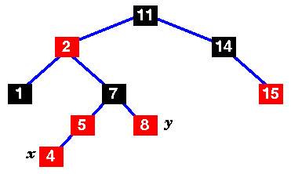

1. Change the colours of nodes 5, 7 and 8

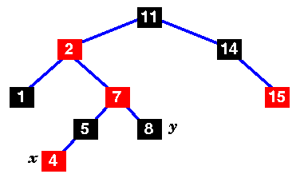

1. Move x up to its grandparent, 7. so we have case 2

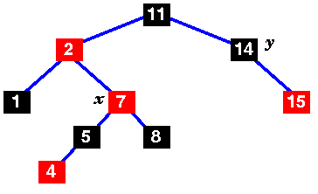

1. Move x up and rotate left.

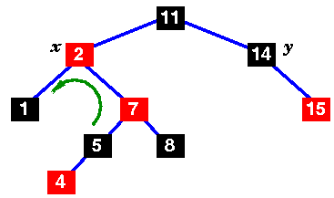

1. Still not a red-black tree .. the uncle is black, but x's parent is to the left

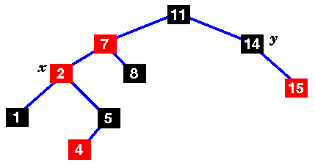

1. Change the colours of 7 and 11 and rotate right

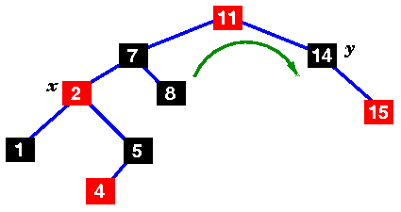

1. This is now a red-black tree, so we're finished!

